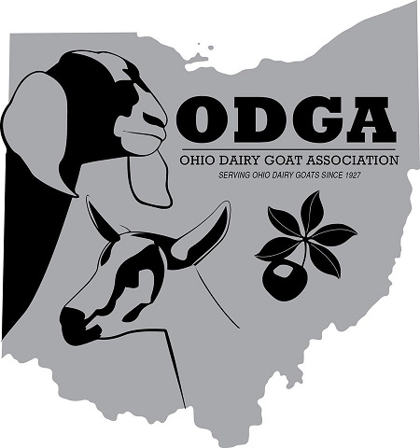
OHIO DAIRY GOAT ASSOCIATION
2021 Buckeye Sale

RULES and PROCEDURES

Thank you for considering the ODGA Buckeye Sale to assist in your dairy goat marketing efforts. We offer the opportunity to promote top quality dairy goats from herds that participate in ADGA production and performance programs, as well as ADGA sanctioned shows. Nominate the very best you have as a representative of your herd breeding and management program. Membership at the time of nomination is not required, but if your animal is chosen for the sale, membership is required to allow your animal to sell.

SALE CHAIR: Jeff Smith, 33677 State Route 541, Walhonding, OH 43843-9777

Telephone: 740-915-1869 E-mail: holsmhills@gmail.com

NOMINATION:
Items to consider when nominating an animal to the Buckeye Sale:

- All nominees must conform to ADGA breed standards, have correct and legible tattoos and be accompanied with an official Registration Certificate at the sale. Animals must be free of physical defects, sound and healthy. Consignments are expected to be raised and managed on a CAE prevention program. Does and bucks over 1 year are required to be tested and found negative for CAE. A Certificate of Veterinary Inspection for interstate travel is required at the time of the sale and is the responsibility of the Consignor.

- Bucks must be born within eighteen (18) months of sale date.

- If a doe consignment is bred, she must be accompanied with a completed service memo at the sale. Any breeding activity, both AI and natural service, must be disclosed in writing in specific details to the ODGA Buckeye Sale Chair before the sale.

Please include with your nomination:

- Photocopy of Registration Certificate, Stamped Duplicate or printed Planned Pedigree

- Photographs of the Nominated animal. Suggested views are: side, front, rear and over the top

- You may include properly labeled pictures of other animals from the pedigree. Identify pictures of relatives of the nominee and indicate their relationship to the nominee (ie, maternal granddam or paternal half-sister, etc).

- Any information that may support your nomination such as linear appraisal scores, official DHIA milk records, show awards and other accolades achieved by animals in the pedigree.

**** PLEASE RETURN YOUR NOMINATION FORM WITH ****
**** DOCUMENTATION NO LATER THAN JUNE 5, 2021 ****
OHIO DAIRY GOAT ASSOCIATION
2021 Buckeye Sale

RULES and PROCEDURES

CONTRACT:
Once a nomination is approved by the Selection Committee, a signed contract with a non-refundable $25.00 fee is to be submitted to secure your spot in the sale. (If the sale cannot be held due to COVID -19 restrictions, the contract fee WILL BE REFUNDED.) Please carefully read and understand the contract before submitting. The contract with the $25.00 fee must be returned by June 10, 2021 to Jeff Smith, Sale Chair.

Consignors must have written permission to use photographs and other records for the marketing/advertising of their animals in the Buckeye Sale that are property of other breeders. Neither the Buckeye Sale Committee nor ODGA shall be held responsible if the consignor fails to secure said permission. Nomination documents and submitted photographs become the property of the ODGA Buckeye Sale Committee.

SALE:
Consigned animals are to be in place by 9:00 am the morning of the sale.

Adequate pens with bedding will be provided by ODGA for sale animals. Consignors are to provide hay, feed and water pails and are responsible for their animal’s care until after the sale.

A full body clip and properly trimmed hooves should be completed before arriving for the sale.

Consignors are encouraged to provide a display board to highlight the accolades of their sale animal. A well-organized presentation of official production records, linear appraisal scores, official show wins and pictures of relatives clearly labeled and indicating their relationship to the nominee (maternal grand dam or paternal half-sister, etc.) tell the story of your sale animal. Any pictures you use should be the best you have available – nothing less than you would put in an ad to market your herd. Copies of photographs and certificates are encouraged as some buyers appreciate being able to keep the display boards used to represent the consignment after the sale.

