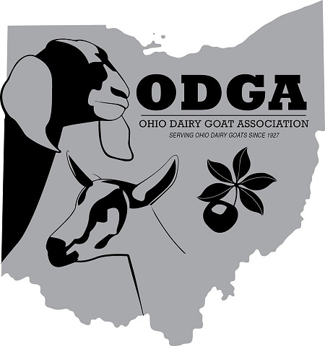
OHIO DAIRY GOAT ASSOCIATION
2021 Buckeye Sale

NOMINATION FORM

The Ohio Dairy Goat Association Annual Buckeye Sale will be held June 25, 2021 following the Buckeye Classic Show that day. We are actively seeking quality animals and would like to present up to 10 animals in the sale. Does and bucks born in 2021 are preferred, but other animals will be considered.

THERE IS NO FEE TO NOMINATE YOUR ANIMAL. Once accepted for the sale, a signed contract and non-refundable fee of $25.00 is required to finalize the contract (due June 10, 2021). If the sale cannot be held due to COVID -19 restrictions, the contract fee WILL BE REFUNDED.

All nominees must conform to ADGA breed standards, have correct and legible tattoos and be accompanied with an official Registration Certificate at the sale. Animals must be free of physical defects, sound and healthy. Consignments are expected to be raised and managed on a CAE prevention program. Does and bucks over 1 year are required to be tested and found negative for CAE. A Certificate of Veterinary Inspection for interstate travel is required at the time of the sale and is the responsibility of the Consignor.

ANIMAL NAME: __________________________________________________________

REGISTRATION #: __________________________________________________________

BREED: ____________________________________ SEX: _________________

OWNER’S NAME: __________________________________________________________

ADDRESS: ________________________________________________________________

PHONE: _______________ E-MAIL: ___________________________________

Please include with your nomination:
- Photocopy of Registration Certificate, Stamped Duplicate or printed Planned Pedigree

- Photographs of the Nominated animal. Suggested views are: side, front, rear and over the top

- You may include properly labeled pictures of other animals from the pedigree. Identify pictures of relatives of the nominee and indicate their relationship to the nominee (ie, maternal granddam or paternal half-sister, etc).

- Any information that may support your nomination such as linear appraisal scores, official DHIA milk records, show awards and other accolades achieved by animals in the pedigree.

**** PLEASE RETURN YOUR NOMINATION FORM WITH ****
**** DOCUMENTATION NO LATER THAN JUNE 5, 2021 ****

Return this form with attached documents to:
Jeff Smith, 33677 State Route 541, Walhonding, OH 43843-9777

For questions or more information, call Jeff at 740-915-1869, or email: holsmhills@gmail.com

