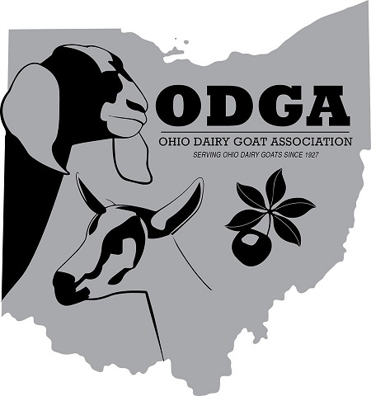
OHIO DAIRY GOAT ASSOCIATION
2021 Buckeye Sale

CONTRACT

This contract is the agreement between the Ohio Dairy Goat Association and:

NAME _________________________________

ADGA ID# ______________________________

ADDRESS_________________________________________________________________________

PHONE ________________________ E-MAIL ___________________________________________

Hereinafter referred to as the consignor. The consignor, in accordance with the nomination rules and procedures and terms of this contract, agrees to consign the _______buck _______ doe known as:

NAME _________________________________________________

REGISTRATION # _____________________ to the ODGA Buckeye Sale June 25, 2021 following the Buckeye Classic Show that day.

The consignor hereby warrants ownership of the animal free and clear of any and all liens or encumbrances.

Consignment animals must conform to ADGA Breed Standards, have correct and legible tattoos, be free of physical defects, and be sound and healthy. If found otherwise, the consignment animal will be returned to the consignor at the consignor’s cost and the contract fee is forfeited to ODGA.

Consignments are expected to be raised/managed on a CAE prevention control program. Consigned does and bucks over 1 year old are to be tested and negative for CAE (Caprine Arthritis Encephalitis) Virus.

Consignment animals must be in place no later than 9:00 AM on the date of the sale.

The ODGA Buckeye Sale committee representative will examine the goats upon arrival. Any necessary veterinary costs are the financial responsibility of the consignor.

Each consignor shall provide upon arrival, a Certificate of Veterinary Inspection for Interstate travel indicating all pertinent health statements, testing and vaccinations within 30 days of the sale, ADGA registration certificate, selling displays, brochures, DNA typing results (if DNA typing was completed) and any updated show or performance information.

Experienced handlers are available to present sale animals unless the consignor prefers to handle their own animal in the sale.

The consignor may place a hold (minimum) price on the consignment animal that must be met or the animal will not be sold. The hold price cannot be raised once the animal is nominated. The consignor retains ownership if the bid does not reach the specified hold price.

Substitution of a consignment animal due to death, illness or injury may be approved after presentation of the fact to the ODGA Sale Chair. ODGA will accept only substitutions of equal or better quality than the original nominee.

The ODGA Sale Chair will decide the sale order. Lot number does not equal sale order.

Animals will proceed to be auctioned and 15% of the sale proceeds will be retained by ODGA, and 85% due to the consignor. Within 30 days of the sale, ODGA will send to each consignor their portion of the sale by check or electronic transfer as agreed upon by both parties.

ODGA will provide reasonable safeguards for the health and safety of the consignment animals while at the event, however, responsibility of the animal and risk or loss, injury or death to the animal remains the consignor’s responsibility until after the sale.

This contract becomes effective upon acceptance of the nominated animal and receipt of this signed contract and payment of $25.00 fee.

HOLD PRICE (Check or fill in amount) NONE:________ $500.00:________ OTHER:________

By signing, consignor agrees to the terms and conditions of this contract.

Signed: ______________________________________________ Date: ________________

Accepted Ohio Dairy Goat Association

by: ____________________________________________ Date: ____________________

**** PLEASE RETURN THIS CONTRACT AND $25.00 FEE ****
**** NO LATER THAN JUNE 10, 2021 ****

Jeff Smith, 33677 State Route 541, Walhonding, OH 43843-9777

