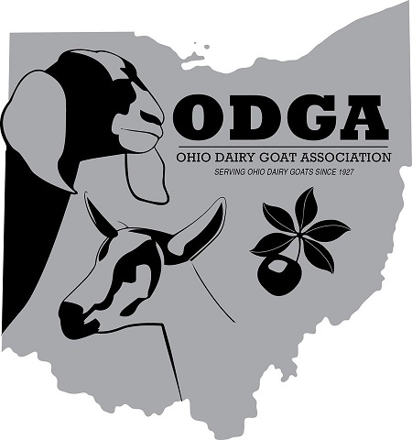
OHIO DAIRY GOAT ASSOCIATION

2021 Youth Ambassador
Application

Ohio Dairy Goat Youth,

Do you love dairy goats? Would you like to help spread the word about dairy goats? If so, consider applying to be a 2021 Ohio Dairy Goat Association Youth Ambassador.

The Youth Ambassador position is open to youth who are Ohio residents and a Youth Member of the Ohio Dairy Goat Association.
- The Junior Ambassador will be selected from contestants who will be 12-15 years old on or before January 1, 2021.
- The Senior Ambassador will be selected from contestants who will be 16-19 years old on or before January 1, 2021.

By applying for a Youth Ambassador position you are agreeing to represent ODGA by attending as many ODGA events throughout the year as possible. Specifically, Ambassadors should plan to attend the Ohio State Fair Dairy Goat Show, the ODGA Buckeye Classic Show and the ODGA Fall Conference. Ambassadors may also attend any of the state and regional club shows representing ODGA. Ambassadors are to submit a written article with a dairy goat topic of their choice for the ODGA Newsletter for National Dairy Goat Awareness in June.

Submission deadline for this application is October 10, 2020. Applications are to be submitted to President Jeff Smith by mail or email. Applicants will be interviewed before the 2020 Annual Meeting on October 17, 2020 and Ambassadors will be announced at the meeting.

Contestants will be judged as follows:
35% Dairy goat knowledge
35% Participation in dairy goat related activities
30% Personality, poise and communication skills

Please fill out the following information as completely and accurately as possible. Additional pages may be attached if needed.

NAME:____________________________________________________________________ 4-H CLUB/ FFA CHAPTER:____________________________________________________
SCHOOL:________________________________________ GRADE:___________________
ADDRESS:_________________________________________________________________
CITY: ____________________________ STATE: _____________ ZIP: _________________ PHONE: _______________________________ EMAIL: _____________________________
BIRTH DATE:_________________________ AGE (as of Jan. 1, 2021):_________________
PARENT OR GUARDIAN’S NAME:______________________________________________
Mail to Jeffrey Smith, 27954 TR 348, Warsaw, OH 43844 or E-Mail: holsmhills@gmail.com
- HOW MANY YEARS HAVE YOU BEEN INVOLVED WITH DAIRY GOATS?
- WHAT IS YOUR HERD NAME AND WHY?

- WHAT BREEDS OF DAIRY GOATS DO YOU OWN AND SHOW?

- WHAT DO YOU LIKE MOST ABOUT DAIRY GOATS?

- WHAT IS THE TOP GOAL FOR YOUR HERD THIS YEAR, IF YOU COULD ONLY ACCOMPLISH ONE?
- WHAT HAVE YOU DONE LOCALLY TO PROMOTE DAIRY GOATS, GOAT KEEPING, AND THE USES OF GOAT MILK?

- LIST ACCOMPLISHMENTS YOU HAVE TO DATE WITH YOUR DAIRY GOATS.

- WHAT WOULD YOU LIKE TO SEE THE ODGA YOUTH PROGRAM OFFER?

- PLEASE WRITE AN ESSAY TELLING US MORE ABOUT YOURSELF AND WHY BECOMING A DAIRY GOAT AMBASSADOR IS IMPORTANT TO YOU. (Additional pages may be added if needed.)

Parent or Guardian:
In the event this applicant is chosen as an ODGA Youth Ambassador, I agree to support them by assuring they attend as many ODGA functions as possible. All ODGA ambassadors must be accompanied by a responsible adult at all functions. Expected attire for ODGA Ambassadors while attending ODGA functions is dress casual, and clean dairy show whites are acceptable if the youth is showing at the event. Ambassadors will be representing ODGA at public events and passing out ribbons and awards at shows. With this in mind, their dress and manners should always set a good example.

ODGA has my permission to photograph and publish photographs of my child within the bounds of their Ambassador service in newsletters, newspapers, the ODGA website, and on the ODGA Facebook Group page.

Signature of applicant:________________________________________DATE:___________

Signature of parent or guardian:_________________________________DATE:___________

Please attach a picture of yourself:

Mail to Jeffrey Smith, 27954 TR 348, Warsaw, OH 43844 or
E-Mail: holsmhills@gmail.com

Deadline: October 10, 2020

